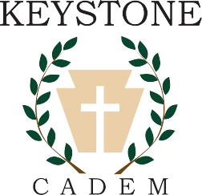

Established 1986

PARENT/TEACHER GUIDE 2025-26

"The fear of the LORD is the beginning of knowledge,

But fools despise wisdom and instruction.

Listen, my son, to your father's instruction

And do not forsake your mother's teaching.

They are a garland to grace your head

And a chain to adorn your neck."

Proverbs 1:7-9

Keystone Academy is a private Christian school specializing in independent study. For over 35 years,

Keystone Academy has provided a structure of support, training, and accountability for home educating families.

©2025

This guide is the property of Keystone Academy which reserves all rights to its contents. This guide must be returned to Keystone Academy upon termination of enrollment.

No part of this guide may be reproduced, stored in any manner, or transmitted by any means without the express, prior, written permission of Keystone Academy.

Table of Contents

**I. Introduction 3**

Bible 3

Keystone Policy 4

II. Semester Grading 4

Keystone Forms 4

III. Junior High 6

A Time of Transition 6

Unit Study 7

Number of Classes 7

Credits and Hours 8

Eighth Grade Graduation 10

Volunteerism and Extra Curricular Activities 10

National Beta Club 10

U.S. Congressional Award 10

IV. High School 11

A Time of Transition 11

High School Planning Chart 12

Course of Study 13

V. Courses and Curriculum Recommendations 13

Individual Junior/Senior High Subjects 13

Summer School 16

Extra-Curricular Activities 17

Sports 17

Class Ring 17

Work Permits and Work Experience 18

Keystone Academy High School Diploma/Graduation Requirements 18

11th grade Appointments 20

Letter of Intent to Graduate 20

Transcript 23

Alumni transcripts 23

College Prep Checklist 9th - 12th 24

Financial Aid: 27

VI. College 29

Concurrent Enrollment 29

College Admission 30

Testing 30

Senior Letter of Recommendation 34

Proficiency Test - CHSPE 35

Appendices 37

High School Planning Chart 37

Senior Letter of Recommendation 37

Curriculum Resources 38

# **Introduction**

Welcome to Keystone Academy as the parent/teacher of 7th - 12th grade students. This supplement covers information that will help you during these important years.

## Bible

Students who attend Keystone are expected to receive a sound Biblical education. Every student must take the Bible every year that they are enrolled with Keystone. Keystone Academy staff considers this the most important part of the student's education, and believes firmly: "The fear of the Lord is the beginning of knowledge." Proverbs 1: 7

Every student in Keystone Academy must study the Bible - not aids or alternative religious materials - the Bible every day.

**There are no exceptions to this requirement.**

## Keystone Policy

The *High School Handbook* is only a reference, and its suggestions do not supersede the policy established by Keystone Academy. If you are uncertainabout a particular issue, it is your responsibility to clarify your question before proceeding with a plan that may result in no credit for your student.

## **Semester Grading**

If you have previously been home schooling, you are probably used to grading once a year in June. Now you will be submitting grades twice each year at the end of each semester in January and again in June. Also, review the section from the Keystone Academy **Parent/Teacher Guide** *Raising a Standard -Grading Student Progress*.

## Keystone Forms

**Beginning in 7th grade, Keystone Academy parent/teachers use the 7-12th grade COS/Final Grade Form found on the school website included with the enrollment packet. In addition, Course Descriptions for each course are now submitted**. There is an optional 7-12th grade Daily Lesson Log form found under the forms tab on the website as well. These forms are also included with enrollment. **How to complete and utilize these forms are covered at the Junior/Senior High Workshop in June, or email Janene@KeystoneAcademySchool.com.**

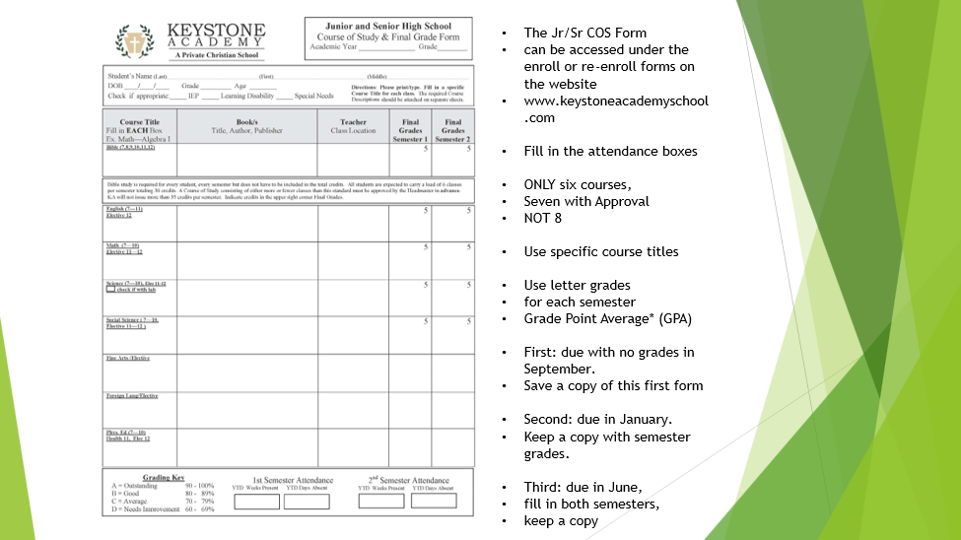

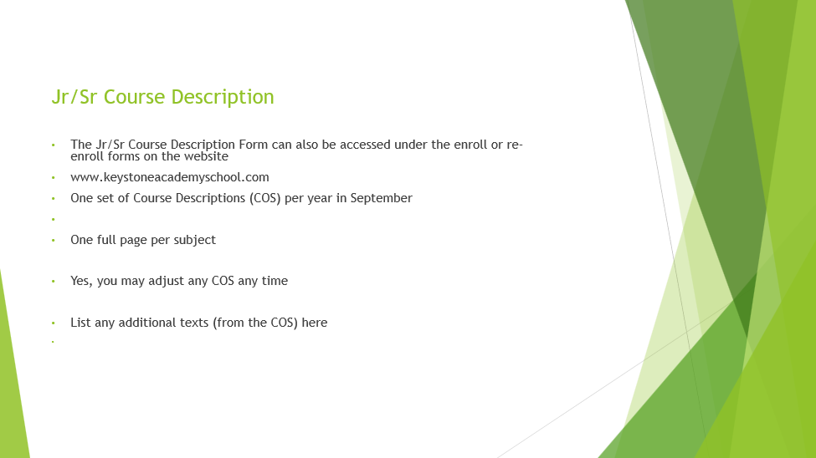 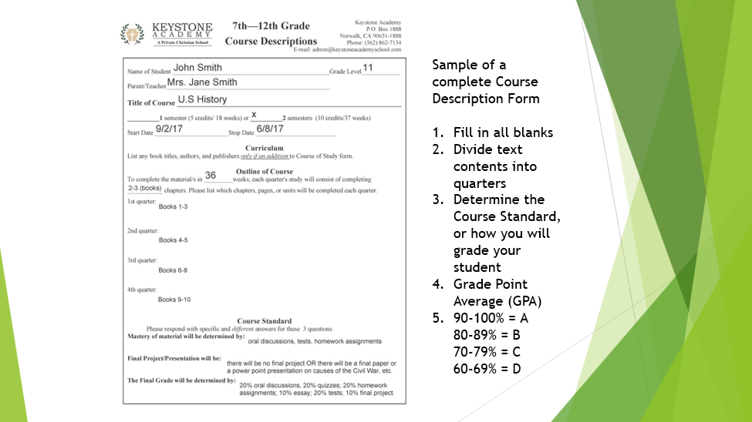

Quarterly Portfolios

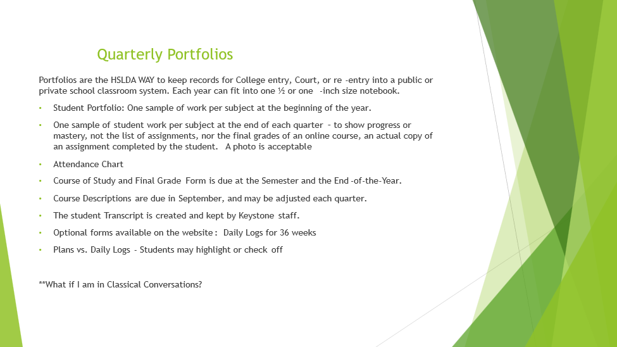Each KA Parent/Teacher is responsible to turn in a Student Portfolio at each of the four Quarterly meetings. A cover sheet will guide you through what to attach at each quarterly meeting in September, November, January, April and June.

# 

# **Junior High**

# 

## A Time of Transition

# 

Junior high school is a time of transition between elementary and high school. Letter grades and testing become more important. Course names move from general, such as Social Science, to the specific, i.e. U.S. History. Classes are now planned on a semester basis. Important habits for high school and later college and adult life include spiritual, physical, and educational/study habits; the habits formed now will serve the young adult for a lifetime.

These early teen years are the time to work on the developing of reasoning skills with a lot of research skill practice drills and a lot of answers to the question WHY???

Junior High is a time for:

* Learning the vocabulary necessary for high school
* Establishing the academic study skills necessary for the future
* Establishing the lifetime discipline of daily Quiet Times
* Establishing the lifetime discipline of Exercise and Wellness Routines

A complete Junior High Schedule will be 6 classes per semester

## Unit Study

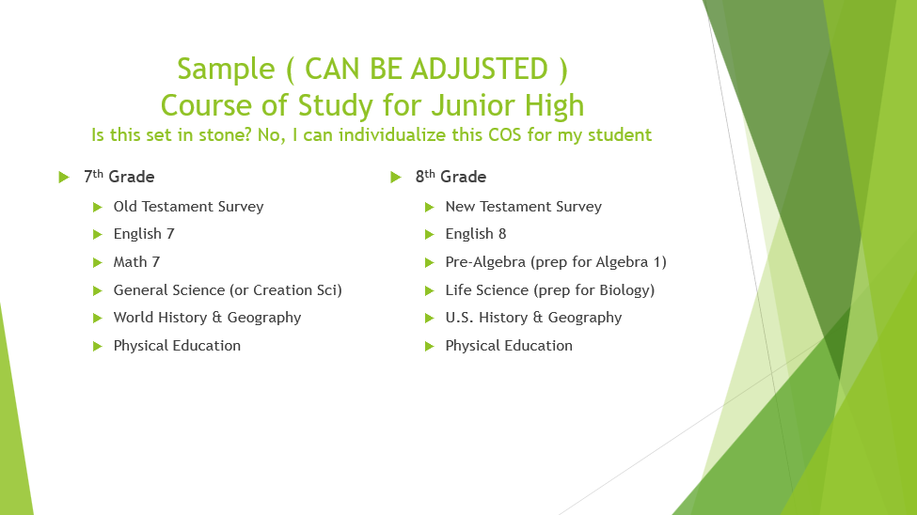

Keystone Academy encourages unit studies even at junior and senior high levels. Classes can be done based on the number of total hours. Teachers using curriculum such as Classical, Konos or Cornerstone Curriculum should work directly with the office to ensure credit will be issued for all courses. Each separate Course of Study and Course Description still needs to always be complete and on file at the office. Daily Lesson Logs are optional but can be useful in showing progress in each subject.

## Number of Classes

A normal public-school load for a 7 - 12th grade student is 6 classes per semester which represents 5 - 6 hours of study. In high school, Keystone will allow 7 classes for students who are planning entry into a college or university which may not allow the Bible units to be counted toward enrollment requirements. By taking 7 classes per semester there are still 6 classes worth of “secular" credit which will be counted by the college of choice. Christian colleges will usually credit all the Bible credits toward entrance.

In the *rare* circumstance that a student needs 7 "secular" subjects and is willing to carry a load of 8 classes he/she may do so. **Bible is required and** will be exchanged to an extracurricular subject with no grade, and no credit. Eight Course Descriptions will be turned in. *The Bible classes will appear* *as extracurricular* on the transcript, allowing the Bible study requirement to enroll with Keystone to be fulfilled. **Pre-approval is required by the headmaster.**

## 

## Credits and Hours

Keystone’s goal is to allow maximum flexibility in accomplishing an individual education. The nature and purpose of a transcript is to reflect in a "universal language" what learning has taken place. The most "universal language" available right now is the public-school standard since most colleges use this model for admission requirements. Each student is aiming toward graduation and maybe going to college. The transcript needs to be precise to indicate that "equivalent" learning has taken place.

For example, a student transfers to a local high school and wants to enroll in Algebra II. The counselor there looks at the transcript to see that the prerequisite, Algebra I, has already been covered. This is done to aid the student in academic success, and to place him/her where he/she belongs. Considering this use for placement, home educating teachers need to reflect accurately on transcripts that the Algebra I class which the student covered, however creatively accomplished, is “equivalent” material, and represents a similar number of hours of instruction and student work to that in a public-school Algebra I classroom.

To be equivalent to a public-school class, there are three ingredients: **Credits**, **Hours** and **Mastery of Curriculum**.

- the *method* - or how the learning takes place -is an area of freedom.

* the *curriculum -* the book, workbook, CD, program or video used, secular or Christian - where there also is a choice. An average classroom would make it entirely through a textbook in a year, and
* the *number of hours* the choice will also be there in the sense that if a student learns or reads quickly, he/she need not work at the slower pace which is required in a classroom with students of mixed abilities. Rather add additional materials to complete the number of hours to an equivalent class. An average class of about 45 minutes per day for 90 days per semester = 85 hours of study. Add some additional homework hours to be accomplished off site. The Keystone accepted documentation will be 90 hours of combined class, lecture, study, and homework per subject per semester. These hours need to be documented in writing on the Cover Sheets or the Extra Curricular activity form for your records.

A student is awarded five credits in California upon satisfactory completion of a semester class with a passing grade of D (usually 60 %) or above.

8th grade College Prep Checklist

## 

Begin in 8th grade to keep the door open for a Diploma and a transcript that will gain entry.

Decide on 3 colleges, secular, community, and Christian. Send a catalog with entry requirements. Use these requirements to plan your high school courses.

Purchase the *High School Handbook* from CHEA of CA.

Purchase and begin working through SAT & College Prep Course by James Stobaugh, or Princeton Review, or other preparatory workbooks or CDs.

Take Pre-Algebra or Algebra I and a foreign language.

Keep grades up: A’s and B’s.

Focus on classes and homework - this helps to master the needed study skills.

Visit college campuses and talk to college students about their experiences.

Keep track of hours spent on extracurricular activities such as Junior Beta Club. Sign up for the Congressional Award Program: Use these guidelines for goal setting and to earn an additional award.

Attend the Junior/Senior Workshop at KA in June to prepare and plan out four-year course of study.

## Eighth Grade Graduation

Eighth graders alongside our Kindergarteners, will be honored at a graduation ceremony in June. This event will include caps and gowns purchased by the parents. There will be a Zoom meeting in April to plan this event, and a Rehearsal on the Monday of Graduation week.

## Volunteerism and Extracurricular Activities

## National Beta Club

The Junior Beta and Senior Beta Clubs are nationally recognized service organizations for students in 4th through 8th grades and 9th through 12th grades, respectively. The Keystone branch was chartered in 2003. **National BETA has recognized Keystone High School as a School of Merit and a School of Distinction. It has achieved 2025 MVP Service status (awarded to only a select few clubs nationwide), dedicating up to 100 hours of service to our school and community.**

Service projects are chosen and completed by the student members. There are leadership opportunities within the club when club officers are elected. Past projects for the Senior Beta Club include serving at the Rancho Los Amigos National Rehabilitation Center in Downey, as well as participating in the Spring Fair's baked potato dinner and basket auction to benefit the Keystone Parent Association. The Junior Beta Club has participated in Operation Christmas Child, Meals on Wheels, the American Cancer Society's Relay for Life, Shoestring Ranch, and created cards for a nursing home. The clubs meet regularly and have an annual Christmas party and end-of-the-year party. Club membership and service hours will be reflected in the transcript, as logged and submitted by the parent/teacher on the Extra-Curricular form found under the Forms tab on the website, or use the Beta Club Form. These hours are reported to our Junior or Senior Beta Club Parent/Teacher. At the Senior High graduation, Senior Beta students receive a gold seal that is attached to their diploma, as well as a gold sash that is worn during the ceremony.

## U.S. Congressional Award

This U.S. program of awards requires the student aged 14 - 23 to be improving himself or herself in four areas: Volunteer Public Service, Personal Development, Physical Fitness, and Expedition/Exploration. There are 3 certificates and 3 medal levels that may be worked through throughout these years. To enroll in this program, go to: [www.congressionalaward.org](http://www.congressionalaward.org).

AmeriCorps

The Americorps Medal is new to Keystone Academy with our first Senior to wear a medal in 2025. We will have more information in future years. This is awarded through KPA – Keystone Parent Association. For more information about this program: https://www.americorps.gov/

# **High School**

## 

## A Time of Transition

High school is a time of preparation and transitioning into the adult world. Testing, such as the College Board PSAT (11th grade), SAT and ACT, becomes important for college bound students. Courses are planned in semester increments with most classes consisting of a full year, 2 semesters of study with specific course names such as Algebra I. The GPA - grade point average - can only be calculated for students whose parents use the traditional A - F scale. The credits per course, 5 per semester of work, also contribute to the GPA, so that completing the hours per course, an average of 90 per semester, becomes an important factor.

High School is a time for:

* Learning vocabulary is necessary for LIFE.
* Establishing the academic study skills necessary for college.
* Establishing the lifetime discipline of daily Quiet Times for LIFE.
* Establishing the lifetime discipline of Exercise and Wellness Routines for LIFE.

Reasoning: The skill of reasoning continues to mature. The teen years are spent sharpening that reasoning skill, with a LOT of emphasis on WHY?

## High School Planning Chart

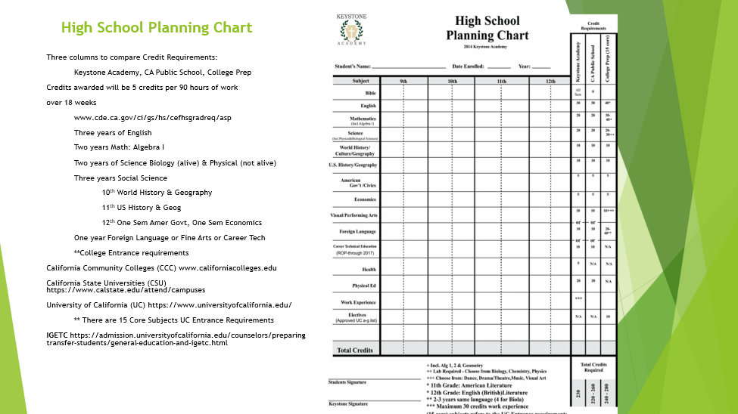

Use the chart in the appendix of this guide to chart out a four-year plan. This will be covered at the Junior/Senior Workshop in June and reviewed at the student’s 11th grade appointment.

## Course of Study

## 

An average public school high school COS would consist of 240 credits - Eight semesters each consisting of six classes completing 5 credits each. A Christian school would commonly have 7 classes per semester, ending with 280 credits because Bible classes are required.

** Remember that your student is special, an individual, not average . . .

Preferred Electives: Typing, Computer, Performing Arts, to supplement degree chosen

# **Courses and Curriculum Recommendations**

## Individual Junior/Senior High Subjects

**Bible:** Each student is required to study the Bible (book, chapter and verse) every school day of each year enrolled. Studies may center around the Sunday school, or church classes already in progress, or use a text or workbook of some type along with, *but not instead of*, daily Bible study. Use this time to get familiar with Bible aides such as a commentary, Bible atlas, dictionary, and concordance. Chronological and topical studies are allowed. Church history is appropriate only as a *compliment* to daily Bible study. Generally, 7th and 10th grades are an Old Testament Survey class, and 8th and 11th grades are New Testament Survey classes. Patrick Henry and other Bible colleges are pleased to see Old and New Testament Survey on transcripts in 10th and 11th grades respectively.

**English**: English 7 is usually a review of elementary English. English 8 prepares for high school. Three years of high school English are required for a diploma. English 9 can be general. For college prep, English 10 is usually Composition, English 11 is usually American Literature, and English 12 is usually English (British) Literature. Abeka and Rod and Staff are good grammar choices. The Institute for Excellence in Writing (IEW) offers a DVD teacher training seminar, *Teaching Writing, Structure and Style*, and is fabulous for teaching writing style. *The Elegant Essay* (also available through IEW) does a great job of teaching the “skeleton” or structure of an essay: developing a thesis, writing introductions and conclusions, creating body paragraphs and transitions between paragraphs. For literary analysis, *Windows to the World* by IEW is terrific using short stories to teach how to identify the theme, conflict, plot structure and other elements of literary analysis. Once the course in completed, you can used with any college-bound booklist for American Literature or British Literature to round out a literary education. Another option is *Teaching the Classics* by Adam and Missy Andrews. This is a DVD seminar that teaches the teacher how to teach literary analysis. (It is to literary analysis what IEW is to teach writing.) Like *Windows to the World*, it also uses short stories to teach concepts. Excellent. Using the Socratic method in teaching literature so is particularly useful for those using a classical homeschool model.

**Mathematics:** Math 7 is usually a review and Math 8 is usually Pre-Algebra. Two years of high school math including Algebra I are required for a diploma. For adulthood, a year of General Math and a year of Consumer Math are good choices. For college prep, the usual 4 years are in this order: Algebra I, Geometry, Algebra II, and Trigonometry/Pre-Calculus. The Saxon books are favorites for home educators. BJU, ABEKA and Switched on Schoolhouse offer good Geometry courses. For parent/teachers who need tutors in math: Key Board Enterprises offers videos for Algebra I & II. Videotext offers an excellent video Algebra and Geometry course. Teaching Textbooks has had many great reviews and offers lectures and problem solutions on CD. BJU also offers these courses on satellite, and Alpha Omega offers these on a flash drive with their Switched-on Schoolhouse. Math U See also offers DVD courses. Khan Academy has good, free online math tutorials and practice. Go to [www.KhanAcademy.org](http://www.khanacademy.org)

**Social Science:** In Junior High, 7th grade is usually some World History and Geography and 8th is usually U.S. History and Geography. Three years of High School Social Studies are required for a diploma. This is the usual sequence: 10th grade World History and Geography, 11th grade US History and Geography (this coincides with 11th grade English - American Lit) and 12th grade one semester of Economics and one semester of American Government. *For Such a Time as This Ministries* offer these history courses from a critical thinking perspective. Inspired by the works of Francis Schaeffer, *Cornerstone Curriculum* offers these 7th - 12th courses woven through *Starting Points* for 7th & 8th and the three years of *Worldviews of the Western World* for high school students. Cornerstone Curriculum is excellent for Patrick Henry College or political science/pre-law majors. Beautiful Feet Books offers a literature approach with lesson plan books for high school World and US History. *A Patriot’s History of the United States* by Schweikart and Allen has gotten excellent reviews as has Hakim’s *History of US* series. Konos offers high school unit studies. ABEKA, BJU, and Alpha Omega have traditional social studies curriculum. Hillsdale College offers free online courses in government and economics. Geography Matters Trail Guide to World Geography is an excellent resource and can be used with multiple grade levels. [www.geomatters.com](http://www.geomatters.com)

**Science:** Science for 7th & 8th grades is usually general and covers a unit or two in each of the many areas to develop the student's interest. Apologia offers *Exploring Creation with General Science* and *Exploring Creation with Physical Science* in book or CD. Cover career possibilities and important science biographies of individuals. In high school, two years of science are required for a diploma. Each year of Physical Science and Biology will complete the requirements. Astronomy, Zoology, or any other science course can also be appropriate. College prep usually requires 3 years in this order: Biology plus Lab, Chemistry plus Lab, and then Physics plus Lab. When choosing a science curriculum, consider that a course that includes video or computer programs which offer lectures and reading only with no hands-on labs would be incomplete for a college prep class. Apologia offers General Science, Physical Science, Biology, Chemistry, Human Anatomy and Physics plus labs from a Christian apologetics perspective. ABEKA and Bob Jones also have good traditional science texts.

**Fine Arts/ Foreign Language:** For junior high, these would be electives. For a Keystone Academy diploma, the student needs one year of either. *Music & Moments with the Masters* and *Adventures in Art* by Cornerstone Curriculum is a good choice for either Art Appreciation or Music Appreciation. How Great Thou Art offers video drawing courses. Some colleges will accept Sign Language as meeting the foreign language entrance requirement, others will not. The most common foreign languages are Spanish, German or French. Most colleges require 2 consecutive years of the same foreign language, with the trend becoming 3 years preferred in the same language. The Learnables, Rosetta Stone, and Power Glide are good curriculum choices for languages. The Latin Road to English Grammar is excellent for teaching Latin and reviewing English grammar at the same time.

**Health:** Health is not required by the CDE and therefore not required for a Keystone diploma. Many topics are typically covered in Biology. For a Christian health text choose *Total Health* which may be studied for a full semester or stretched to a year. Available from Christianbook.com. Sex education is covered as part of preparation for life and part of the health course. It is not usually listed as a separate subject. Consider Christian curriculum which emphasizes purity and abstinence before marriage and healthy sexual relations within the context of marriage.

**Driver’s Education:** is not required. Check the DMV website for local schools. Rainbow Resource catalog does have a Driver’s Education curriculum from Starline Press as well as an interactive software *Driving School* CD. [www.rainbowresource.com](http://www.rainbowresource.com) .Driver’s Education is extracurricular; no credit is issued.

**PE:** Both 7th and 8th grades still have full years of PE as requirements. A high school diploma requires 2 years of daily PE. Various PE classes are sometimes offered at Academy Days. Swimming has been available through Keystone Academy sponsored classes at the YMCA as interest allows. Participation in a Keystone partnered CIF sports team will meet this requirement. Please use this time to instill a lifelong love of exercise and do it heartily unto the Lord. Do not skimp here.

**Testing:** Testing is not required in California private schools; private schools are not required to take the California High School Exit Exam given to public school students. Taking the ACT and College Board Tests (PSAT and SAT) can lead to scholarships for college applicants. One semester (5 credits) of elective credit in Test Skills may be issued to the student who is working through a computer program or textbook in preparation for tests when 90 or more hours are documented. Stanford Achievement Tests (also called SAT’s) are available through BJU for K - 12 and now are taken online. BJU also offers the Iowa Assessment Test which can be ordered and taken at home. James Stobaugh has an excellent *SAT College Preparation Course for the Christian Student*. Also recommended: *Princeton Review, or SAT College Prep Course*. The CHSPE, California High School Proficiency Exam, can be taken to exit high school early. chspe@cde.ca.gov or 916-319 - 0330.

**Electives:** The rest of the required credits for graduation will fall into the elective category. Keystone allows most electives requested. Subjects that prepare for a future career also belong here. Work experience credits are also electives.

**Extra-Curricular**: Piano, other classes, employment, and volunteer activities should be logged by hours and reported on the Extra Curricular form for mention on the transcript.

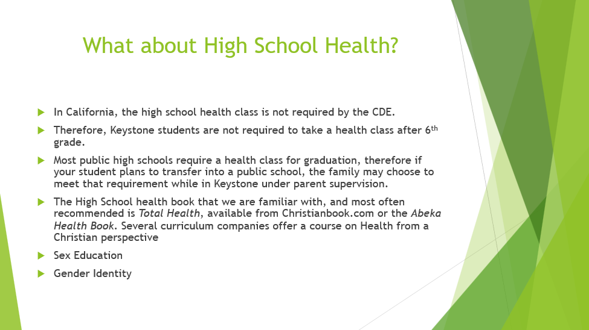

## Summer School

Students who are in year-round school do not get additional summer school credit because July and August are part of their regular 36-week academic year. Summer school credit is awarded when students who have completed their regular 2 semester school year between September and June do additional work during the summer. It is possible to use summer school to repeat failed classes.

Keystone recommends students get a two week break before starting summer school and two weeks after finishing before returning to regular studies for the next year. In the 8 weeks left, a maximum of 10 credits, 2 different one semester classes (5 credits each), or a one-year class (two semesters of the same subject for 10 credits) representing about 180 hours of study is all you may schedule. (8 weeks x 5 days = 40 days). 180 hours divided by 40 days means the student must study an average of 4 hours per day.) Again, the three ingredients for any semester class remain the same.

Keystone Academy will issue no more than 10 units of summer school credit. To receive the credit, **the course must be pre-approved,** the student must be enrolled, and all paperwork must be completed on Re-Enrollment Day. Summer school classes taken in July or August will be posted to the previous year. The family *must be enrolled before classes begin, and Course Descriptions must be on file in the office*. The Summer School Course of Study/Final Grade form is under the Forms tab on the school website. Regular monthly tuition applies.

## Extra-Curricular Activities

Public schools handle karate, piano lessons, jobs, volunteer activities and other such subjects as extra-curricular and usually do not list them on the transcript. These are activities that are done on a personal student basis outside the classroom. Keystone Academy will list extra-curricular activities if the Parent/Teacher *documents the hours and submits an Extra-Curricular form found under the Forms tab on the website.* Extra-curricular activities can be documented through the Junior and Senior Beta Clubs. Turn in a final copy of the Extra-Curricular form indicating hours accomplished with the final grade form at the semester and end-of-the-year.

## Sports

As student interest allows, our high school students have the opportunity to participate in a variety of CIF sports including boys/girls volleyball, boys/girls basketball, and baseball. New sports may be added as interest arises. To be eligible for CIF, students must maintain a 2.0 GPA. ALL paperwork must be current. In addition to semester grades, students must submit progress reports at the 1st and 3rd quarters. This form is located under the Forms tab on the school website. Each year a separate athletic packet will be emailed to high school students detailing the requirements, sports offered, expectations, fees, etc. for participation. CIF has firm guidelines therefore ALL paperwork MUST be submitted in a timely manner and GPA must be verified or the student WILL NOT be eligible to participate.

## Class Ring

Walmart can produce a class ring with the name Keystone Academy around a stone. Go to Walmart.com to order. Many Keystone families have purchased class rings through Walmart. Jostens will also do custom rings.

## Work Permits and Work Experience

Work Permits may be obtained through Keystone Academy. The permit is requested ***after*** the student has a job, for that particular job. The permit will have to be signed by Keystone staff, and the employer. The permit is granted for *that particular job*, so change in job requires new permit. More information on work permits can be found in the *High School Handbook.* Keystone Academy will allow a maximum of 30 units of elective Work Experience credit at 5 per semester to be granted over a 3-year time.

Senior Year Activities

Each year, seniors and their parent/teachers plan special activities throughout the year and assist in planning the graduation ceremony in June.

## 

## Keystone Academy High School Diploma/Graduation Requirements

## 

Minimum Age: 17 years old

Successfully complete four full years of academic study. Minimum of 11th and 12th enrolled in Keystone. 9th-11th grade please plan for six classes, maximum of seven.

12th grade please plan for five classes, maximum of seven.

Complete a minimum of 230 units over the four year study

Maintain at least a C grade point average (GPA).

Proficiency Test: Diplomas are not granted based on passing the CHSPE. Private schools in California also are not required to take the high school exit exam.

Course Requirements for Graduation

**Bible:** 40 credits, 4 full years, or every year enrolled

**English:** 30 credits 3 full years

**Math:** 20 credits, 2 full years including Algebra I

**Social Science:** 30 credits consisting of 1 year World History & Geography, 1 year of U.S. History and Geography, and 12th grade - 1 semester Economics and 1 semester American Government

**Science:** 20 credits, 2 full years including biology and physical science

**Physical Ed:** 20 credits, 2 full years

**Fine Arts /or/**

**Foreign Lang:** 10 credits, 1 year of Fine Arts OR 1 Year of Foreign Language*

**Electives:** 5 credits per semester as needed to complete the minimum of 230

credits**

* Sign Language may fulfill the Foreign Language requirement; check with your college of choice.

**Work experience: A maximum of 30 credits at 5 per semester over 3 years.

## 11th grade Appointments

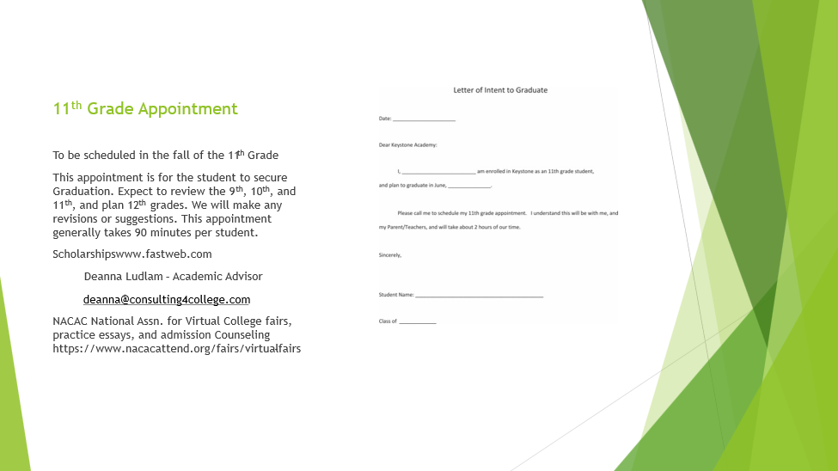

Students who plan to graduate from Keystone **are required** to make an appointment through the office with Mrs. Gerl during the 1st semester of their 11th grade year. This is a personal appointment for the student, which usually takes about 1 1/2 hours. Parent-teachers are encouraged to attend as well. Classes for 9th, 10th, and 11th grade are plotted on the four-year planning chart. Classes for 12th grade are projected, and parents, students and Keystone staff all sign the agreed upon plan for 12th grade. Keystone representative, parent and Student will sign the chart. Keystone Staff will follow through to check the 12th grade Course of Study in the fall and spring of the senior year.

Please print, sign and bring the Letter of Intent to Graduate to the meeting.

## Letter of Intent to Graduate

Date______

Dear Keystone Academy:

I, am enrolled in Keystone as an 11th grade student, and plan to graduate in June, _______________.

My 11th grade appointment is ________________ (date) at ___________(location)

I understand this will be with me, and my Parent/Teachers, and will take about 2 hours of our time.

Sincerely,

Student Name

Class of ____________

(this page left intentionally blank)

## Transcript

A transcript is simply a written record documenting what learning has taken place and when it has taken place. Keystone Academy will post the grades on a transcript and provide copies as needed to future schools or colleges. A junior high transcript covers work done in 7th and 8th grades. A high school transcript covers 9th -12th grades. These transcripts list classes by semester and post semester grades.

**A transcript is simply a record of what learning has taken place.**

## Alumni transcripts

All Keystone Alumni receive three free official transcripts upon graduation. Future copies can be ordered online under the Keystore tab. Requesting Keystone Academy transcripts for colleges with less than two- weeks’ notice incurs a rush fee of $25.00. **Please, plan ahead**.

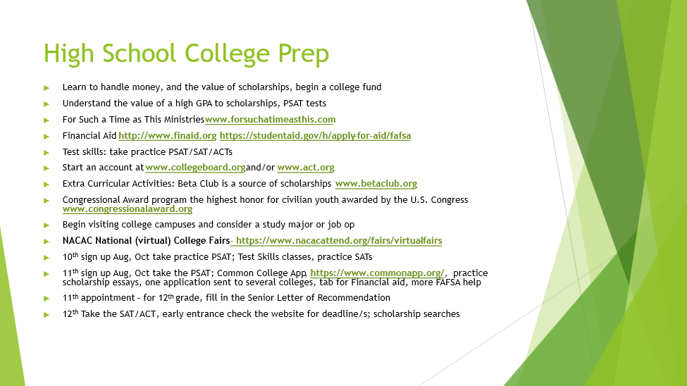

## College Prep Checklist 9th - 12th

**9th Grade**

Re-read the *High School Handbook* from CHEA of CA, project the four-year plan.

Research where to take the PSAT in 10th or 11th grade. Begin three-year prep program from SAT Prep book or Princeton Review.

Take more challenging courses to expand knowledge and stretch the mind. If you are heading to UC or CSU: know the college admission requirements. Plan courses accordingly.

Keep the GPA up to 3.0 or above (A’s and B’s).

Participate in school activities.

Use the Extra Curricular or Beta Club form to keep track of the hours spent on extracurricular activities such as Beta Club or Yearbook. Continue the Congressional Award program: Use these guidelines for goal setting and to earn an additional award, or AmeriCorps Program.

**10th Grade**

Study to take the PSAT this year and/or in 11th grade; use results to plan improvement.

Visit each of the colleges. Make an appointment with a financial aid counselor. Begin looking for scholarships.

Continue through the SAT Prep book.

GPA of 3.0 or above is still important.

Attend college information program/s and visit campuses (Biola is close and usually hosts a Christian college fair in October). The National Association for College Admission Counseling (NACAC) also hosts a college fair with hundreds of colleges in attendance. [www.nacacfairs.org](http://www.nacacfairs.org)

Use the Extra Curricular or Beta Club form to keep track of the hours spent on extracurricular activities such as Beta Club or Yearbook. Continue the Congressional Award program: Use these guidelines for goal setting and to earn an additional award, or AmeriCorps Program.

**11th Grade**

Register in August for the PSAT; take the PSAT in October. Use results to plan improvement. Good scores here = scholarships.

______ Make sure to attend picture day in September; you will need the student ID for the PSAT.

In September, email the Letter of Intent to graduate. 11th grade appointment with Mrs. Troutt and Mrs. Gerl.

Take the SAT and ACT in the spring; take the CHSPE if you wish.

GPA of 3.0 or above is still important; the second semester of your junior year is very important to colleges

Begin formal applications for scholarships. Parents: Your taxes this year and next year will be used to apply for scholarships so file in January.

Consider taking 1 or 2 courses at a junior college, or CLEP, or online college study.

Apply to college/s. Look for scholarships.

Keep track of hours spent in extracurricular activities such as Beta Club or yearbook. Continue the Congressional Award program: Use these guidelines for goal setting and to earn an additional award.

Assist and attend the June Keystone Academy Graduation; serve at reception for the senior class.

______ Use the Extra Curricular or Beta Club form to keep track of the hours spent on extracurricular activities such as Beta Club or Yearbook. Continue the Congressional Award program: Use these guidelines for goal setting and to earn an additional award, or AmeriCorps Program.

**12th grade**

Register in August for the SAT & ACT; take the test/s in November.

**For homeschoolers, you will need these scores for your GPA verification needed to apply for a Cal Grant (college financial aid) which is due March 2.**

Make sure your senior course matches your 11th grade agreement.

______ October – Apply for FAFSA online. Parents: Your taxes from the “prior, prior year” will be used to apply for aid and scholarships. For example, you are filing a 2017-18 school year FAFSA. Your taxes from 2015 will be used to determine eligibility. You may use the IRS Data Retrieval Tool to automatically import tax information into your FAFSA, which makes the process much easier. **FAFSA is needed for Cal Grant which needs to be mailed before the March 2 deadline.**

Use the Extra Curricular or Beta Club form to keep track of the hours spent on extracurricular activities such as Beta Club or Yearbook. Continue the Congressional Award program: Use these guidelines for goal setting and to earn an additional award, or AmeriCorps Program. Continue the Congressional Award program: Use these guidelines for goal setting and to earn an additional award.

Talk to friends and school leaders about letters of recommendation. Fill out the Senior Letter of Recommendation located in the appendix of this guide to assist Keystone in drafting a letter of recommendation if required.

Apply to colleges of choice.

Apply for scholarships, using the above letters.

Re-take the SAT or ACT if better scores are needed.

Consider and take SAT II and CLEP tests.

GPA of 3.0 or above is still important.

February: Acceptance letters begin coming; make sure all applications are submitted with GPAs as well as financial applications.

## 

## 

## 

## Financial Aid:

## 

**CCS Financial Aid Profile**

Student toll free number for profile registration:1-800-239-5888

or online at www.collegeboard.com

**National Merit Scholarship Corporation**

1-847-866-5100

**SallieMae CollegeAnswer service**

1-888-888-3460 or https://ww2.salliemae.com/

**Next Stop College**

1-800-227-6734, [nextstopcollege@collegeboard.org](mailto:nextstopcollege@collegeboard.org)

**Fund your Future**

www.edfund.org from the California Student Aid commission is for high school counselors.

**FAFSA**

This should be done in October of your senior year. <https://fafsa.ed.gov> *Be very careful.* This stands for the FREE Application for Federal Student Aid. Watch the URL address. It is a government website and there are no fees involved. If you google “FAFSA” there are fraudulent companies with a similar web address that will take your money to fill out this free form for you. Even families who feel they may not qualify for government aid, need to complete this. Most colleges will want this done before determining other grants or scholarships. **A completed FAFSA is needed by the March 2 deadline and is used for determining Cal Grant awards. On the FAFSA form, choose homeschool, do not choose private high school.**

**Cal-Grants**

www.calgrant.org These are scholarships funded by our tax dollars. A couple of excellent, copyrighted month-by-month lists of what to do to apply for scholarships.

**MARCH 2 DEADLINE. A completed FAFSA as well as GPA verification are needed.   For homeschoolers, you will need SAT/ACT scores for GPA verification.  PLAN AHEAD!!**

[**http://www.certicc.org**](http://www.certicc.org)

Resources for funding college and offers general information on California colleges.

**Fastweb**

[www.fastweb.com](http://www.fastweb.com) – Database of private sector scholarships and grants

**Other Resources:**

*College Admissions* - a Guide for Homeschoolers by Judy Gelner

*Earn & Learn,* a booklet about Cooperative Education by Octameron Associates

Fin*ancial Aid Officers* What they do to you and for you by Octameron Associates

*The A’s and B’s of Academic Scholarships* - 100,000 ways to beat the high cost of College by Octameron Associates

*The High School Handbook* by Mary Schofield

## 

# **College**

## Concurrent Enrollment

High school students are allowed to enroll in concurrently with a local college if permission is granted from the high school. Some colleges have their own forms; some ask you to bring a Keystone Academy form. All must be signed by the principal (Headmaster or Administrator). Keystone Academy will accept college units toward high school graduation. For the transcript the class will be entered with a * note "see attached transcript" so that any future college will give the student college credit. To be included as part of the student’s high school transcript, the parent/teacher is responsible for getting the proper college transcripts forwarded to Keystone from the college in a timely manner.

Community colleges may expect an unofficial transcript as well as their form/s signed by Keystone staff. Please, plan. Contact the office for the unofficial transcript. Rush fee of $25.00 if less than two-week notice.

Coastline Community College: <https://www.coastline.edu/admissions-and-records/dual-enrollment> . Keystone students have successfully taken many online courses here while enrolled in high school. Admissions: 11460 Warner Ave, Fountain Valley

Students from Keystone have also successfully been dually enrolled at Long Beach City College, Fullerton College, Cerritos College, GoldenWest College and Rio Hondo College. See their websites and search for high school concurrent or dual enrollment.

In addition to community colleges, private Christian colleges provide for concurrent enrollment. Keystone students have been dually enrolled with Master’s College, Grand Canyon University, Southwestern, Colorado Christian, and Hope International.

## College Admission

## 

To date, all Keystone Academy alumni who have applied got in to a college of their choice. Applying early and looking for good scholarships are usually a key. Apply during the late junior or early senior year. By applying in the late junior year (for the appropriate fall - 2 years later) a student can be accepted for the fall term 2 years in advance giving the college finance counselors a full year to help with financing. Doing well on the SAT and ACT testing also gives the student an edge here. Taking them in the junior year enables the student to take them again in the senior year if scores need to be improved.

## Testing

**PSAT/NMSQT/SAT/AP - College Board Testing www.collegeboard.org**

These are college entry tests given by The College Board organization. Most colleges no longer require for admission; however, as homeschool student, you will SAT or ACT scores instead of a GPA verification for a Cal Grant. Keystone’s SAT/College Board ID # is 052179.

The **PSAT/NMSQT** has a dual purpose; it is a practice test for the SAT, and it is a qualifying exam for the selection of National Merit Scholars. It is suggested that students take the test their sophomore year as a practice run and again their junior year when they are able to qualify for scholarships. [www.collegeboard.org](http://www.collegeboard.org)

The **SAT**  (not to be confused with the Stanford Achievement Test with the same initials) is designed to test math and verbal skills. Beginning in 2021, The College Board has eliminated the optional essay component to the test. While the PSAT is a practice test, the SAT is used for college admissions. The student should take it for the first time in the spring of his junior year then again a second time in the fall of his senior year. Waivers for fees are available. Full information is available from www.collegeboard.org. The parent/teacher and student must plan this in advance to allow for signatures from the office on the applications as needed.

The **SAT Subject Tests** have been discontinued by The College Board as of 2021. Students are encouraged to take Advanced Placement exams in place of the subject tests.

**AP - Advanced Placement Courses -** The following information comes from HSLDA:

Advanced Placement courses are rigorous courses taken in high school but taught on a college level.

In order for homeschoolers to label courses as “Advanced Placement” on their high school transcripts, the course syllabus must now be pre-approved by the [College Board AP Central](http://apcentral.collegeboard.com/apc/Controller.jpf). (AP® is a trademark and to use it without approval is illegal.) Besides studying the course material, students also prepare to take an Advanced Placement test administered through the [College Board](http://www.collegeboard.com/testing/). If students score well enough on the AP test, students can earn college credit for the course. Individual colleges set their own policies regarding which AP tests they recognize and what score must be attained to receive credit. For more information see [Testing](http://www.hslda.org/highschool/testing.asp). The following individuals/organizations offer AP® courses online to homeschoolers:

[Debra Bell’s Resource Center](http://www.debrabell.com/)

[AP Calculus AB: online interactive class for homeschool student (highschoolmathlive.com)](https://www.highschoolmathlive.com/apcalculusab.html)

[Homeschool-Teachers.com](http://www.homeschool-teachers.com/)

[HSLDA Online Academy](http://academy.hslda.org/college-prep-courses/?HSLDAAPList)

[Courses: Diplomas & Courses: IU High School: Indiana University](https://iuhighschool.iu.edu/diplomas-courses/courses.html)

[Keystone National High School](http://keystoneschoolonline.com/curriculum/advanced-courses" \l "online-high-school-advanced-placement-courses)

[Northstar Academy](http://www.northstar-academy.org/)

[Pennsylvania Homeschoolers](http://www.aphomeschoolers.com/)

[UNHS Courses | Browse Courses | University of Nebraska High School](https://highschool.nebraska.edu/courses)

[Home - Write From The Heart](https://writefromtheheart.org/)

**Supplemental AP Test Prep**

[D.I.V.E. AP Physics](http://www.diveintomath.com/science-1/)

**ACT**

This college entry test is given by ACT Incorporated. This test is useful to college admissions officers in comparing applicants from different schools with widely varying courses and grading standards. It is a three hour multiple choice exam with four sections: English, Math, Reading and Science reasoning. The student should take the ACT for the first time during the spring semester of his junior year and again in the fall of his senior year. Information is available at [www.ACT.org](http://www.act.org).

**Which test should my child take?** Consult a current college guide book. Certain types of students do better on the different tests. The SAT is now using common core math so many advisors recommend homeschoolers take the ACT as an alternative test.  Both tests now do not deduct for wrong answers so if a student runs out of time at the end of the test a student should pick one answer choice and bubble it in down the remainder of the test. Again, test prep guidebooks can be a big help in deciding which tests to take and how to study for them, as well as your strategy in taking them. The ACT and the College Board produce an ACT/SAT Concordance Table that allows users to compare scores from ACT and the SAT. www.act.org/concordance.

**SAT/ACT Test Prep**

For help in improving test scores [www.kaptest.com](http://www.kaptest.com) offers customized individual areas of weaknesses. Eknowledge - [www.eknowledge.com](http://www.eknowledge.com) offers a free/low cost online course. Khan Academy also has a free test prep course: <https://www.khanacademy.org/test-prep/sat>. The SAT College Board also has a SAT question of the day. Go to [www.collegboard.org](http://www.collegboard.org) for more information. ACT offers free ACT Academy which is a free personalized online learning tool and test practice program. [www.act.org/academy](http://www.act.org/academy). ACT also offers a free test preparation booklet [www.act.org/theact/testprep](http://www.act.org/theact/testprep).

**Please, plan ahead.**

**CLEP Testing**

The College Board who offers the above tests also offers CLEP - College Level Entrance Program. Students who pass these tests often qualify for college units, and can eliminate various classes. For example, a Keystone student taking Algebra I could also study through the CLEP prep book for the Algebra test, and take the CLEP test at the end of his high school year. If he passes the test, he gets college credit, and will not have to repeat the class later in college. www.collegeboard.org gives full info including a listing of colleges who accept CLEP units.

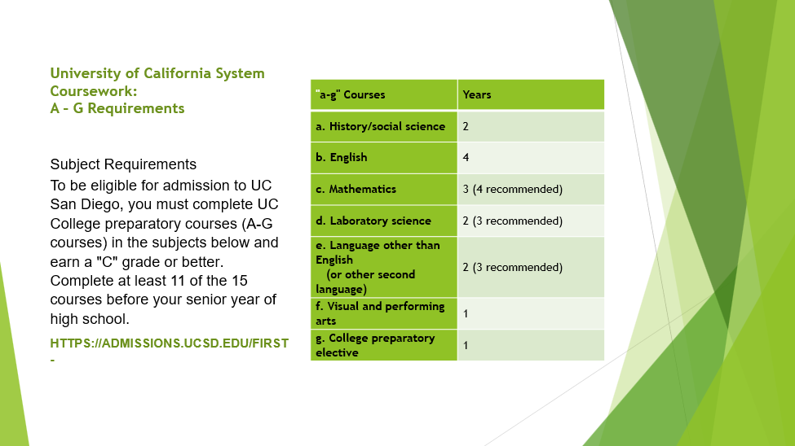

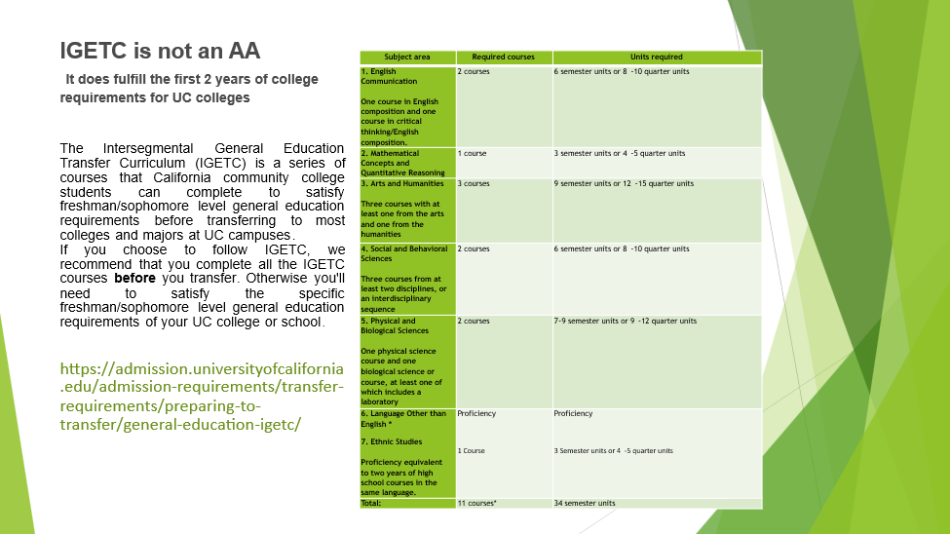

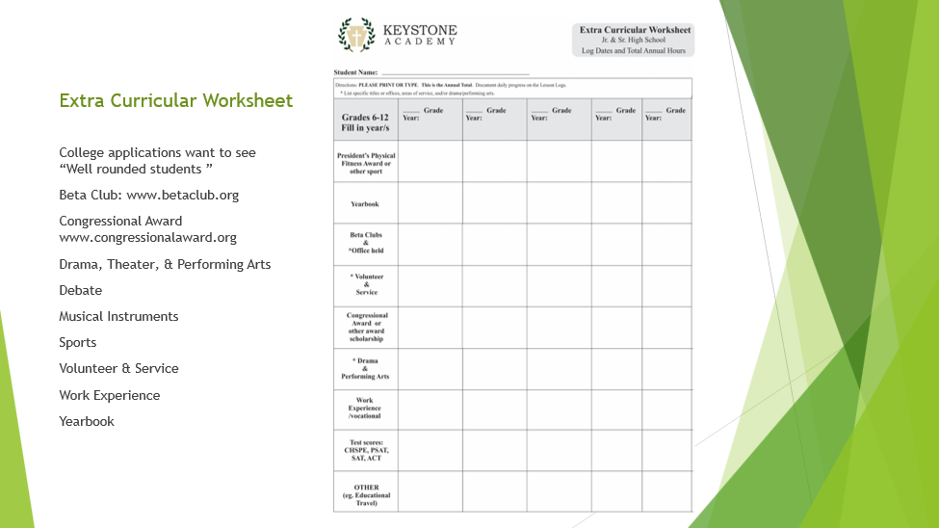

## Senior Letter of Recommendation



Keystone Staff is often asked to provide a Letter of Recommendation. Please print, fill in, and return the Senior Letter of Recommendation form at the end of this handbook. Once this form is completed and returned, please allow two weeks for delivery.

## Proficiency Test - CHSPE

The California High School Proficiency Examination (CHSPE) may be taken by students who are over 16 years of age as *an* *alternative* to graduation or *a supplement*. If passed, the student will receive a High School Equivalency Certificate from the State of California. Keystone Academy does not grant a diploma based on passing this test. Keystone Academy grants a diploma on the criteria listed on the next page under Graduation Requirements. Some Keystone Academy alumni have both the CHSPE certificate and a diploma from Keystone earned by completing the full 4 years. In the event that the Keystone Academy student passes this test and goes on to college rather than earning a diploma from Keystone Academy, then Keystone Academy becomes the last school of record - that is - the last school where the student attended high school. A copy of the CHSPE certificate should be sent to the office, and it will be posted on the transcript. The student would refer any requests for high school transcripts to Keystone. Please notify the Keystone Academy office if your student is taking the CHSPE. From the CHSPE website, “If you are planning to continue your studies at a college or university, contact the admissions office to check if the CHSPE will be accepted.”

The State Department of Education controls the CHSPE and is solely responsible for its content.

Workbooks and computer curriculum are available from most bookstores to prepare for this test. Use the Keystone teacher ID card for a discount.

The test takes 3 ½ hours and consists of English, language arts and mathematics. Calculators not permitted.

For further info: [www.chspe.net](http://www.chspe.net)

CHSPE - “What if I elect to get out early?”

and other Last School of Record students

***Q.*** *If my student opts to take and pass the CHSPE early, will he/she get to graduate from Keystone Academy?*

***A****. No, the CHSPE certificate is equivalent to a diploma in CA.*

***Q.*** *If they want a Keystone diploma, what do they do?*

***A.*** *Pass the CHSPE plus complete all requirements on the High School Diploma Requirement checklist.*

|  |  |
| --- | --- |
| **For graduates, Keystone offers:** | **CHSPE only:** |
| Cap & gown | No Keystone Academy cap and gown |
| Graduation ceremony in June | No Graduation ceremony |
| Keystone Academy diploma & cover  which is awarded at the ceremony | No Keystone Academy diploma.  Parents may purchase a personal one from HSLDA |
| March down aisle in cap & gown with special recognition | No special recognition at Keystone Academy Graduation |
| The yearbook: senior page | Listed under current grade, no senior page |
| Cume File/Transcript | Keystone Academy becomes the “last school of record and keeps the transcript. The student or future schools request transcripts from Keystone Academy. The student should provide a copy of the CHSPE to be listed on the transcript. The parent/teacher must be sure to turn in all final grades. |

# **Appendices**

## High School Planning Chart

## Senior Letter of Recommendation

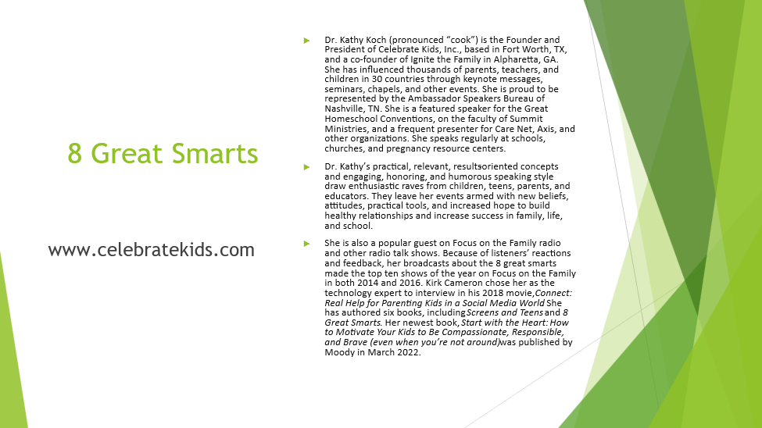

High School Handbook

Keystone recommends that you purchase a copy of the *High School Handbook* by Mary Schofield. Her book will help you in designing a Course of Study and then writing Course Descriptions each year. It is available at [www.cheaofCA.org](http://www.cheaofca.org). Parents who have worked with Course Descriptions, credits, and hours throughout junior high will have learned these skills and developed confidence for planning a high-school Course of Study.

HOWEVER, the *High School Handbook* is only a reference, and its suggestions do not supersede the policy established by Keystone Academy. If you are uncertainabout a particular issue, it is your responsibility to clarify your question before proceeding with a plan that may result in no credit for your student.

## Curriculum Resources

See a more complete listing in the Parent/Teacher Guide.

**Social Science**

For Such a Time as This Ministries 814/479 - 7710. wwwforsuchatimeasthis.com

Hillsdale College – free online government class, economics class and more. <https://online.hillsdale.edu/>

Dave Ramsey finance curriculum for junior high and high school. <http://www.daveramsey.com/school/foundations/>

**Science**

*Apologia Ed Ministries, Inc*., 1-666-524-4724 www.apologia.com offers each high school course plus lab sets.

*Home Science Tools* - www.hometrainingtools.com offers complete lab sets at reduced rates for most science curriculum.

Science lab equipment and kits: Castle Heights Press, Inc., 2578 Alexander Farms DR. SW Marietta, GA, 30064. 1-770-218-7998.

Science lab packages for home including Biology, Chemistry, and Physics. NASCO. [www.enasco.com](http://www.enasco.com)

Apologia Ed Ministries., Inc, 1-888-524 - 4724 www.highschoolscience.com

**Mathematics**

Key Board Enterprises Algebra I & II, Geometry. 5200 Heil St., #32, Huntington Beach, CA 92649 714) 840 - 8004

Video Algebra I/II and Geometry course. Recommended by Dr. Wile of Apologia. <http://videotext.com/>

Teaching Textbooks offers a computer cd math curriculum. <http://www.teachingtextbooks.com/>

**Electives**

Christian family life - Whole Heart Ministries 1-254-797-2142

**Foreign Language**

Power Glide cd’s: 1-800-597-0910

The Learnables 1-800-237 - 1830 [www.learnables.com](http://www.learnables.com)

Rosetta Stone: <http://www.rosettastone.com>

